Website: glebelands.ea.dundeecity.sch.uk Twitter: @glebelandsps

Newsletter – September 2019

A warm welcome to everyone for the new session!
Open Afternoons

Please look out for invitations from your child’s class to an open afternoon this term or next. This may take the form of an assembly or classroom-based learning activity or any way in which the children would like to share their learning with you. Invitations may be created by the children (please check schoolbags) and/or through dojo message.

We look forward to seeing as many of you as possible at these events.

Healthy Eating

We continually promote healthy eating with the children through the curriculum and at our healthy tuck shop and school dinners. While we appreciate that some children like to bring their own snacks to school to eat at morning break, it would be helpful if parents/carers could encourage these to be as healthy as possible to avoid children over-indulging in sweets, crisps and chocolate. Fizzy drinks are not permitted.
Staff Information
We welcome on board two newly qualified teachers this year, Miss Ismail (P2/3) and Miss Johnston (P3), who are both very enthusiastic and committed to providing exciting learning experiences for the children in their care. Miss Stitchell will be working alongside both teachers as well as covering each class one day a week.

I am delighted to share with you that Miss Stitchell is expecting her first child. She is very excited about the prospect of motherhood and I know you will wish to join us in extending our best wishes to her and Mr Jamieson. She will be with us until February next year before taking her maternity break.

Absence from School
If your child is going to be absent from school for any reason, it is important that you contact the school to keep us informed. (tel. 438834)

In the interests of safety, if a child has not arrived at school and we have not heard from you by 9.30am, office staff will contact you via text message on the first day of absence.

Please remember, if your child has been suffering from vomiting and/or diarrhoea, they must be clear of all symptoms for 48 hours before returning to school.

Parking
Parking on Baffin Street and the surrounding area continues to cause major problems for pupil safety at the beginning and end of the school day. The chaos which ensues from thoughtless parking is putting our children at risk. It is not possible to have safety officers in attendance at all times, therefore I appeal again to those of you who insist on parking outside the school gates, without due consideration for others, to consider safer alternatives.

Safer Routes to School leaflets, produced by the Council, are available on the school website and offer advice on safe parking areas near the school and encouragement to use other modes of transport. “Be Safe” is one of our school rules for all school users.

Parent Council
Our Parent Council members do a great job helping to shape school improvement through sharing ideas and fundraising. We are always looking for new members who are interested in contributing their thoughts and skills.

Our first meeting of the year is on Tuesday 1st October at 6.00pm in school. We hope to see a good turnout.

Term 1
It is great to see all of our children back again after the summer break and settling in well to the school routine, including our new primary ones. We have got off to a flying start with the following events:

- some of our classes visiting the Dundee Flower and Food Festival;
- P4/5 giving a brilliant performance on the music stage at the Flower and Food Festival, singing “In the Band”;
- the pupils of P6A contributed to the Climate Change agenda by staging a playground “march” to get the message across that it is everyone’s duty to protect their planet;
- our P7 pupils learned what to do and what not to do in the event of danger at the annual Safe Taysiders event.

Macmillan Coffee Morning
P6 pupils are supporting this great charity by organising a coffee morning for parents on Friday 27th September. Tickets are still available from Mrs Faulkner’s class.

Playground
The wooden challenge course and ship which sit on the grass area of our infant playground is now no longer safe to use. At present, it is cordoned off by a temporary fence and should be removed within the next few weeks. We plan to give some thoughts to a replacement and will seek children’s views on this.

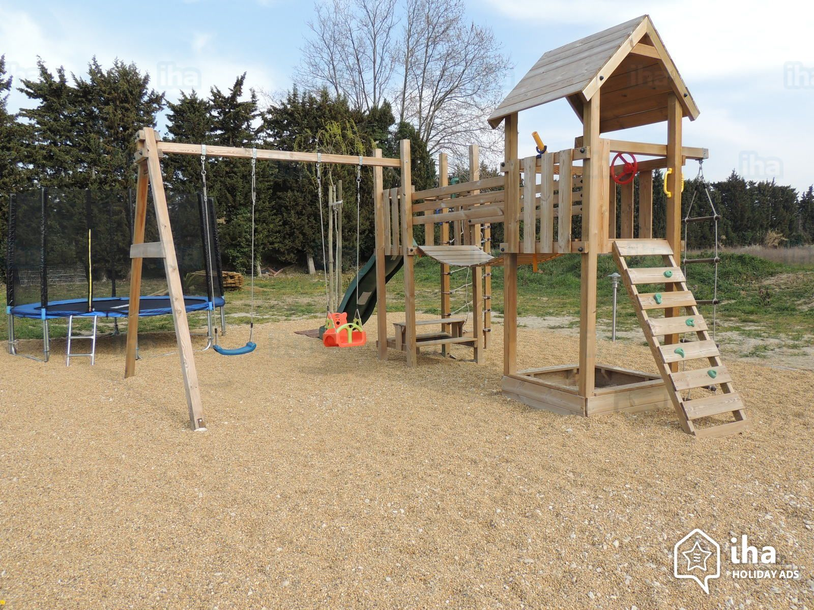

A reminder that no dogs are allowed on school premises.
Please also note that there is a no smoking policy which applies to all areas of the school grounds.

Clothing & Personal Belongings
Our children, as always, are looking very smart in their school uniform. Thank you for your support with this.

We are already adding to our stock of lost property. Please make sure that your children’s clothing and personal belongings are labelled. This helps staff to recover missing items and to avoid mix ups over similar items when getting changed at PE times.
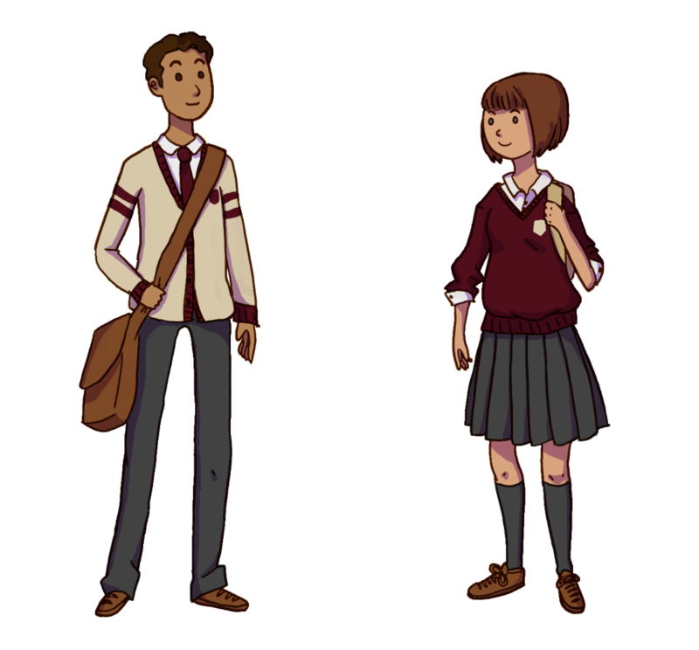

A number of pupils are forgetting to bring PE kit. We would appreciate your help in reminding them. PE is an important part of the curriculum in developing social skills as well as fitness and exercise for healthy lives. Pupils do not sit out of PE if they forget their kit but it is better if they can move around more freely in appropriate clothing.

Date | Time | Event
Term 1  Tuesday 24th September  Thursday 26th September  Friday 27th September  Monday 30th September  Tuesday 1st October  Tuesday 1st October  Wednesday 2nd October  Thursday 3rd October  Thursday 3rd October  Thursday 3rd October  Friday 4th October  Term 2  Tuesday 22nd October  Thursday 24th October  Thursday 24th October  Thursday 14th November  Friday 15th November  Monday 18th November  Tuesday 19th November  Wednesday 20th November  Wednesday 4th December  Wednesday 18th December | 7.00pm  1.45pm  9.45am to 11.45am  All Week  6.00pm to 7.30pm  1.15pm  1.30pm  1.30pm  1.50pm  1.45pm  All Day  tbc  All Day  Every Thursday  All Day  All Day  6.00pm to 8.00pm  3.45pm to 6.00pm  6.00pm to 7.30pm  3.45pm to 5.30pm  1.45pm | Morgan Academy Open Evening for P7  P1A, P1B, P1/2, P2 Open Afternoon  Macmillan Coffee Morning – organised by P6A & P6B  Activities and Challenges to develop maths skills  Parent Council Meeting  P3 Open Afternoon  P2/3, P3/4, P7 Termly Treat  Termly Treat – all other classes  P7 Visit to Morgan Academy for Maths Week  P2/3 & P3/4 “Paddington” Open Afternoon  In-service Day – school closed to pupils  Girls’ Football Event at DISC  Flu Immunisation  Kodaly Music for P1A, P1B, P1/2, P2 and P2/3  In-service Day – school closed to pupils  In-service Day – school closed to pupils  Parents’ Evening  Parents’ Evening  Parent Council Meeting  Fun in Athletics Cluster Event at DISC  Christmas Service at Trinity Church
Holidays  Thursday 3rd October  Friday 4th October  Thursday 14th November  Friday 15th November  Friday 20th December | School closes for October holiday at 3.15pm and re-opens on Monday 21st October at 9.00am.  Additional In-service Day – school closed to pupils  In-service Day – school closed to pupils  In-service Day – school closed to pupils  School closes for December holiday at 12.00 noon and re-opens on Monday 6th January at 9.00am.
“Be the Best Possible You”
Vision and Values
Our new vision and values underpin everything we do in Glebelands. This includes how we learn and how we behave. We are working on embedding the language of these across the school. In essence, Glebelands is:

“an inspirational community striving for excellence in learning through a culture of innovation, challenge, inclusion and the celebration of success”
This is supported by our values – those things we truly believe will make a difference:

AMBITION INCLUSION RESPECT SUPPORT

